# Rossmoyne Senior High School

### Year 11 Examination, 2015

### Question/Answer Booklet

**SOLUTIONS**

# MATHEMATICS

# METHODS

# UNITS 1 AND 2

## Section Two:

## Calculator-assumed

|  |  |  |  |  |  |  |  |  |
| --- | --- | --- | --- | --- | --- | --- | --- | --- |
| Student Number: In figures |  |  |  |  |  |  |  |  |

In words

Your name

## Time allowed for this section

Reading time before commencing work: ten minutes

Working time for this section: one hundred minutes

## Materials required/recommended for this section

##### *To be provided by the supervisor*

This Question/Answer Booklet

Formula Sheet (retained from Section One)

##### *To be provided by the candidate*

Standard items: pens (blue/black preferred), pencils (including coloured), sharpener,

correction fluid/tape, eraser, ruler, highlighters

Special items: drawing instruments, templates, notes on two unfolded sheets of A4 paper, and up to three calculators approved for use in the WACE examinations

## Important note to candidates

No other items may be taken into the examination room. It is **your** responsibility to ensure that you do not have any unauthorised notes or other items of a non-personal nature in the examination room. If you have any unauthorised material with you, hand it to the supervisor **before** reading any further.

## Structure of this paper

|  |  |  |  |  |  |
| --- | --- | --- | --- | --- | --- |
| Section | Number of questions available | Number of questions to be answered | Working time (minutes) | Marks available | Percentage of exam |
| Section One:  Calculator-free | 7 | 7 | 50 | 52 | 35 |
| Section Two:  Calculator-assumed | 12 | 12 | 100 | 98 | 65 |
|  | | | **Total** | 150 | 100 |

## Instructions to candidates

1. The rules for the conduct of examinations are detailed in the school handbook. Sitting this examination implies that you agree to abide by these rules.
2. Write your answers in this Question/Answer Booklet.
3. You must be careful to confine your response to the specific question asked and to follow any instructions that are specified to a particular question.
4. Spare pages are included at the end of this booklet. They can be used for planning your responses and/or as additional space if required to continue an answer.

* Planning: If you use the spare pages for planning, indicate this clearly at the top of the page.
* Continuing an answer: If you need to use the space to continue an answer, indicate in the original answer space where the answer is continued, i.e. give the page number. Fill in the number of the question that you are continuing to answer at the top of the page.

1. **Show all your working clearly**. Your working should be in sufficient detail to allow your answers to be checked readily and for marks to be awarded for reasoning. Incorrect answers given without supporting reasoning cannot be allocated any marks. For any question or part question worth more than two marks, valid working or justification is required to receive full marks. If you repeat any question, ensure that you cancel the answer you do not wish to have marked.
2. It is recommended that you **do not use pencil**, except in diagrams.
3. The Formula Sheet is **not** to be handed in with your Question/Answer Booklet.

Section Two: Calculator-assumed (98 Marks)

This section has**twelve (****12)** questions. Answer **all** questions. Write your answers in the spaces provided.

Working time for this section is 100 minutes.

Question 8 (6 marks)

A and B lie on the circumference of a circle of radius 20 cm.

The chord AB subtends an angle of  at O, the centre of the circle.

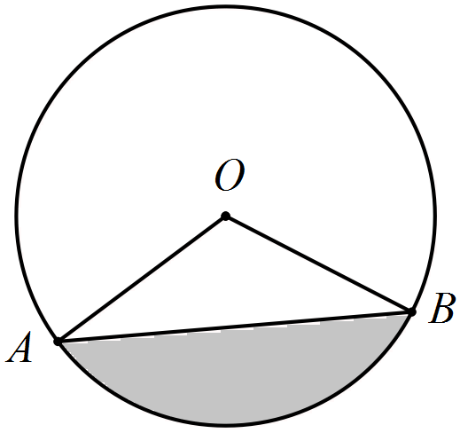

(a) Determine the exact length of the minor arc AB. (2 marks)



(b) Determine the length of the chord AB. (2 marks)



(c) Determine the shaded area bounded by the chord AB and the minor arc AB. (2 marks)



Question 9 (5 marks)

A small body moves in a straight line such that its displacement from the origin after t seconds is given by , where x is the displacement in meters and .

(a) At what time does the body pass through the origin? (1 mark)



(b) Determine the velocity, v, of the body when  seconds. (2 marks)



(c) Calculate the displacement of the body at the instant that it is stationary. (2 marks)



Question 10 (8 marks)

An analysis of the 210 students in their final year of school determined that 35 chose to study Physics, 45 chose to study Chemistry and 151 chose neither of these subjects.

(a) Determine the number of students who chose to study both Physics and Chemistry.

(2 marks)



(b) Determine the probability that a randomly selected student chose to study

(i) Chemistry. (1 mark)



(ii) Physics but did not choose Chemistry. (1 mark)



(iii) Chemistry given that they chose to study Physics. (2 marks)



(c) Is there any indication that choosing to study Chemistry is independent of choosing to study Physics? Explain your answer. (2 marks)

No.



Question 11 (8 marks)

The value V, in thousands of dollars, of an office computer system t months after installation, can be modelled by the equation .

(a) Calculate the value of the system at the time of installation. (1 mark)



(b) Draw the graph of the value of the system for  on the axes below. (3 marks)

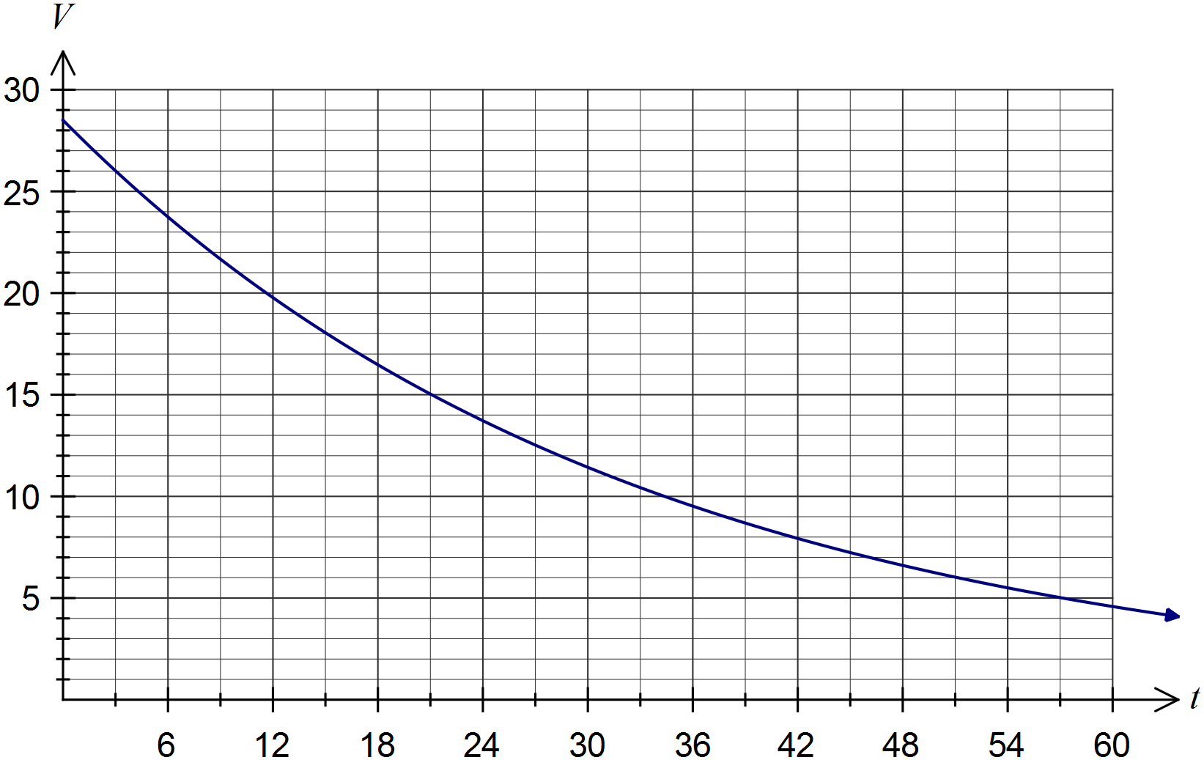

(c) Determine the value of system, to the nearest hundred dollars, after two years. (2 marks)



(d) Company policy is for the system to be replaced after 5 years or when its value has decreased by 80%, whichever occurs first. When will the system be replaced? (2 marks)



Replaced after 53 months.

Question 12 (9 marks)

An analysis of new cars sold recently showed that 80% had automatic transmission (event A) and that 68% were classified as having a small to medium sized engine (event S). It was also noted that 56% of cars had both automatic transmission and a small to medium sized engine.

(a) Use the above information to complete the all the probabilities in this tree diagram.

(5 marks)

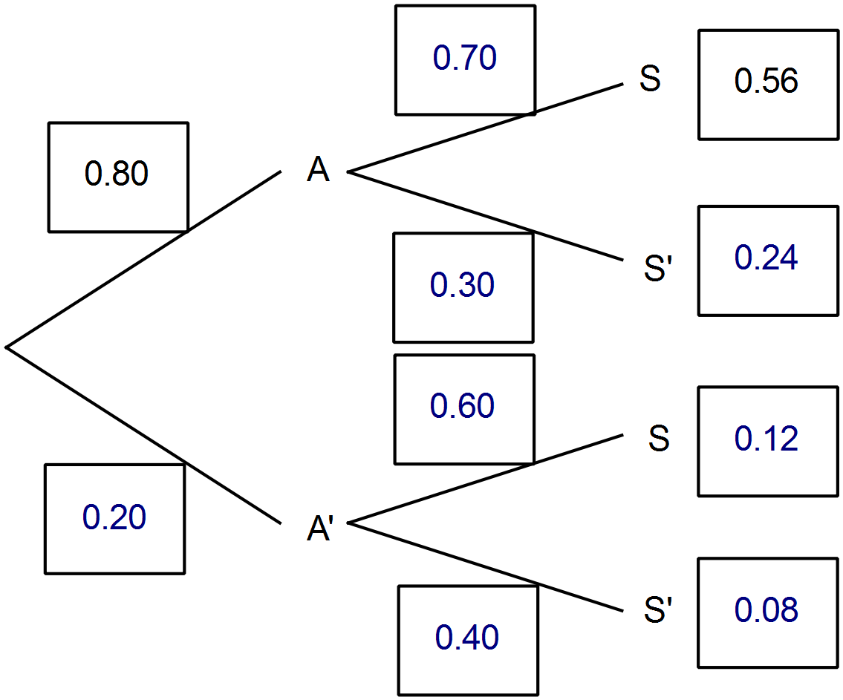

(b) Determine the probability that a randomly selected car will

(i) have a small to medium sized engine given that it does not have automatic transmission. (1 mark)

0.6

(ii) have a small to medium sized engine or have automatic transmission. (1 mark)



(iii) have automatic transmission given that it has a small to medium sized engine.

(2 marks)



Question 13 (9 marks)

(a) The depth of water at a mooring in a tidal inlet during a particular day can be modelled by the function , where d is the depth of water in meters and t is the time in hours after midnight, as shown below.

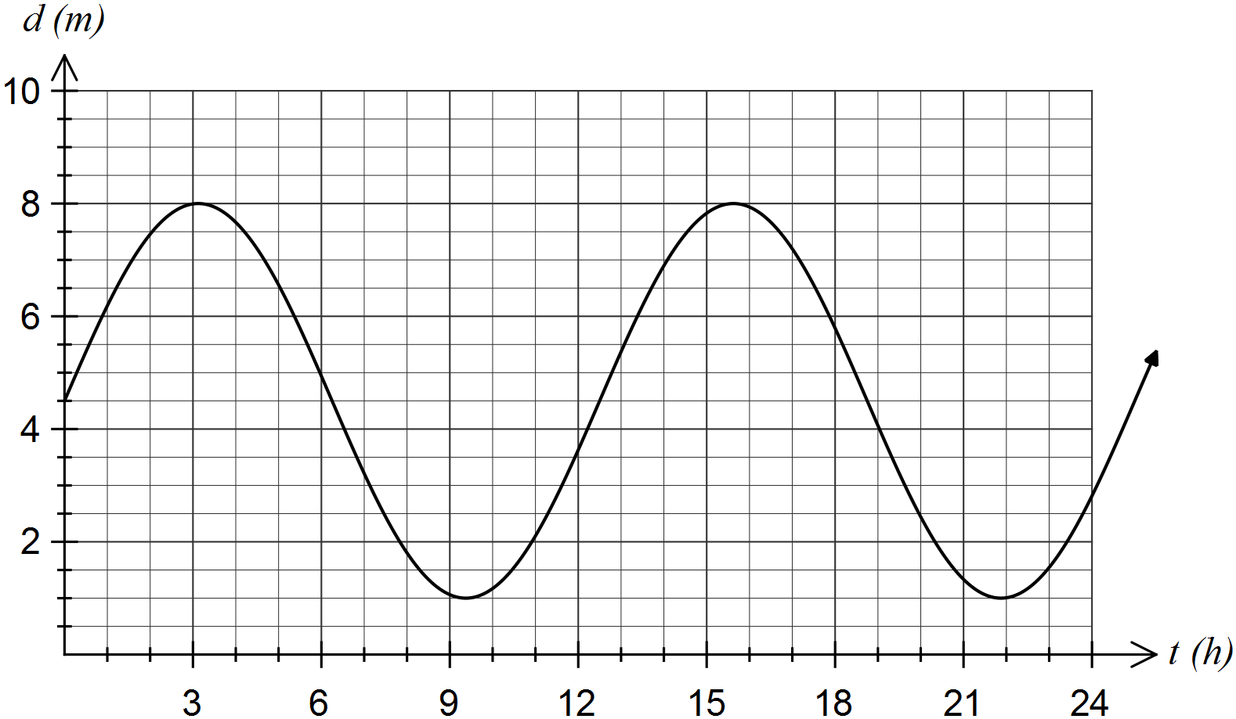

(i) Use your calculator to determine the time, to the nearest minute, at which the depth of water is first a minimum. (2 marks)



(ii) For what percentage of the first 12 hours is the depth less than 2 metres? Give your answer rounded to one decimal place. (3 marks)



(b) If A and B are acute angles with  and  show that .

(4 marks)



Question 14 (10 marks)

Part of the graph of  is shown below.

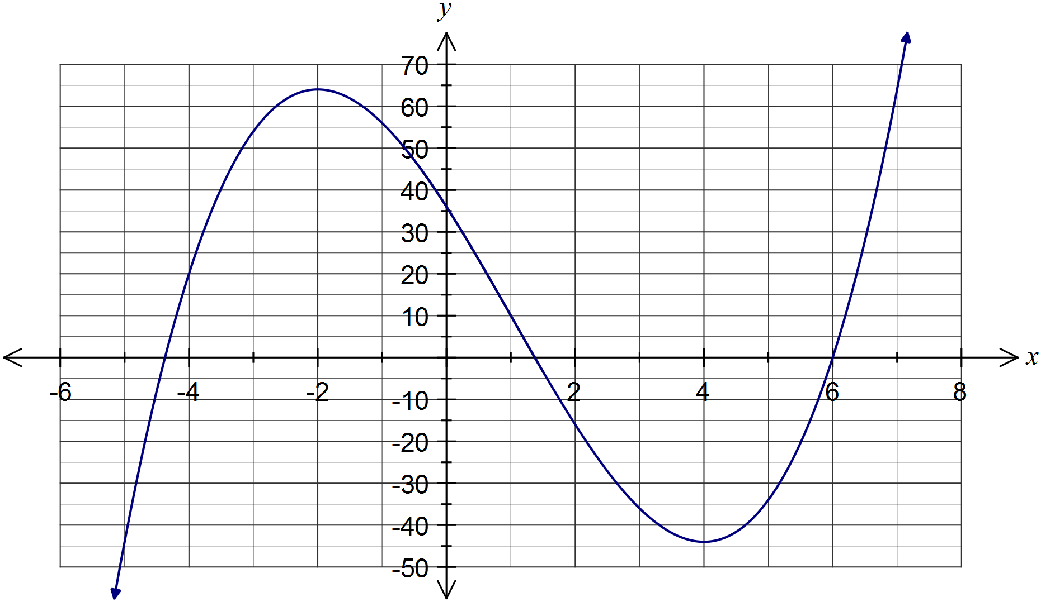

(a) Using calculus techniques, determine the coordinates of both stationary points of the graph. (4 marks)



(b) Neatly complete the graph of . (3 marks)

(c) Show that the equation of the tangent to the graph at  is . (3 marks)



Question 15 (8 marks)

The graph of the function  is shown below, where a and b are integer constants.

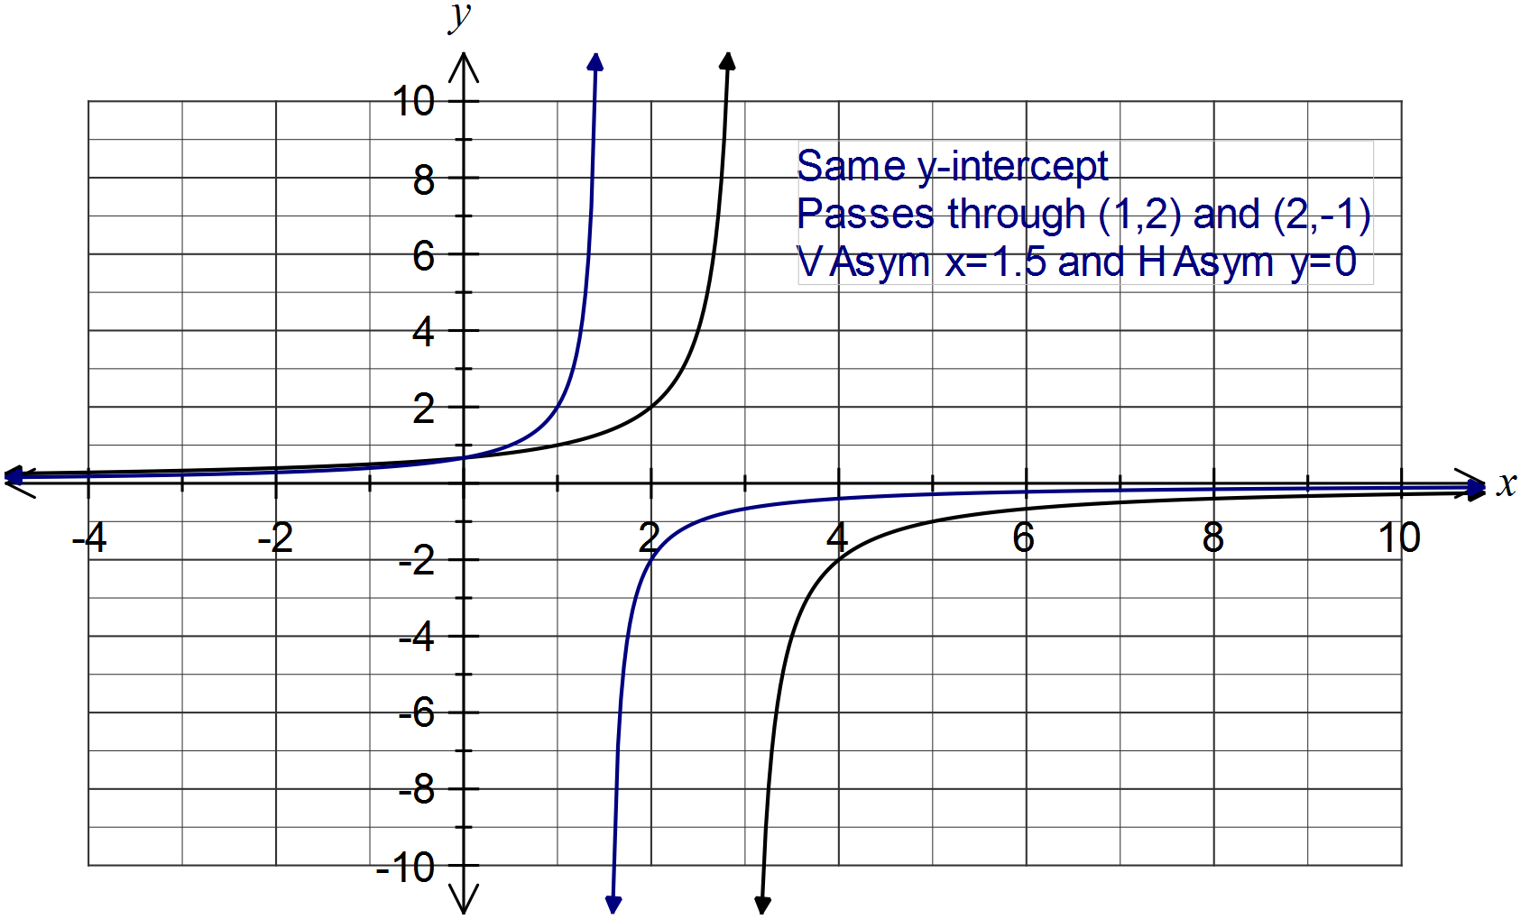

(a) Determine the values of a and b. (2 marks)

From vertical asymptote, .

Using point such as (2, 2), 

(b) State the domain and range of . (2 marks)

Domain: 

Range: 

(c) The function g is given by .

(i) Describe how to transform the graph of  to the graph of . (1 mark)

Dilate graph parallel to x-axis by scale factor $\frac{1}{2}$.

(ii) Draw the graph of  on the previous axes. (3 marks)

Question 16 (9 marks)

A toy train is moving around a circular track of radius 1.5 m and during the first minute completes 9.5 laps of the track. In each subsequent minute, as the batteries run down, the train travels 90% of the distance travelled in the previous minute.

(a) Determine the distance travelled by the train during the fifth minute. (3 marks)



(b) During which minute does the train first travel less than one complete lap of the circuit?

(2 marks)



During the 23rd minute.

(c) Determine the time, to the nearest minute, that the train takes to travel a distance of at least 500 metres. (2 marks)



Train takes 8 minutes.

(d) Show that the train will never complete more than 95 laps of the circuit. (2 marks)



Train cannot exceed sum to infinity for this sequence, which is 95 laps.

Question 17 (9 marks)

The owners of a market stall know that they can sell 100 greeting cards per day if they charge $5 per card, giving a daily revenue of $500. The owners estimate that for every 50 cent increase in price, they will sell five fewer cards per day.

(a) Complete the table below. (3 marks)

|  |  |  |
| --- | --- | --- |
| Number of 50 cent increases, x. | Price ($) | Number of cards sold |
| 0 | 5.00 | 100 |
| 1 | 5.50 | **95** |
| 2 | **6.00** | 90 |
| 3 | **6.50** | **85** |
|  |  |  |

(b) Show that the daily revenue from selling cards, after  50 cent price increases, is given by . (1 marks)



(c) Using calculus techniques, determine the amount that should be charged per card to maximise daily revenue. State how many cards will be sold at this price and the maximum revenue. (5 marks)



Question 18 (8 marks)

(a) A committee consisting of 10 senior members and 12 junior members has decided to select five of its members to form a subcommittee.

(i) Determine the number of different subcommittees that can be selected. (1 mark)



(ii) Determine the number of different subcommittees that can be selected that contain only senior members. (1 mark)



(iii) Determine the probability that a randomly chosen subcommittee contains at least one junior member. (2 marks)



(b) If  and , determine  in each of the following cases:

(i) A and B are mutually exclusive. (1 mark)



(ii) . (1 mark)



(iii) . (2 marks)



Question 19 (9 marks)

The first three terms of a sequence are, in order, .

(a) Determine the value of x and the sixth term of the sequence if the sequence is an arithmetic progression. (4 marks)



(b) Determine the value of x and the sum of the first ten terms of the sequence if the sequence is a geometric progression with a positive common ratio. (5 marks)



Additional working space

Question number: _________

Additional working space

Question number: _________

This examination paper may be freely copied, or communicated on an intranet, for non-commercial purposes within educational institutes that have purchased the paper from WA Examination Papers provided that WA Examination Papers is acknowledged as the copyright owner. Teachers within Rossmoyne Senior High School may change the paper provided that WA Examination Paper's moral rights are not infringed.

Copying or communication for any other purposes can only be done within the terms of the Copyright Act or with prior written permission of WA Examination papers.

*Published by WA Examination Papers*

*PO Box 445 Claremont WA 6910*